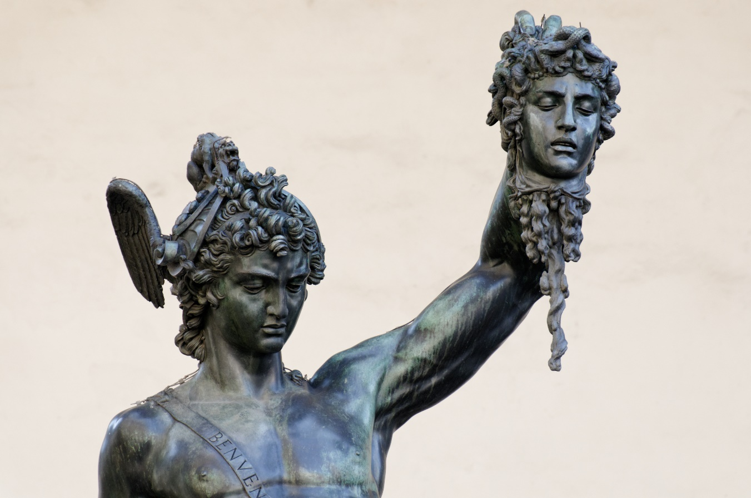
Perseus
the Brave

by Roberto Trostli
adapted by Alberdine Regoort
& Mirije Obbema

Cast of Characters
Acrisius, King of Argos 1
Danae, his daughter
Perseus, son of Danae and Zeus scene III
Perseus 2. scene IV
Perseus 3 scene V &VI
Perseus 4 scene VII
Priest of Apollo
Priestess of Apollo
Soldier1
Soldier 2
Dictys, a fisherman of Seriphos
Dictys’s wife
Polydectes, King of Seriphos scene III
Polydectes scene VII
Servant1
Servant 2
3 Lords
Lord 1
Lord 2
Lord 3
Hermes
Pallas Athena
The Three Gray Sisters Medusa, the Gorgon The two Gorgon Sisters
Sister 1
Sister 2
sister 3
Medusa
A chorus of all the characters

Scenes

1. The Temple of Apollo in Delphi
2. On the shores of rocky Seriphos
3. In the court of King Polydectes
4. On the road to Athens
5. On the island of the Gray Sisters
6. On the island of the Gorgons
7. In the court of King Polydectes

PROLOGUE

Chorus: Sing of the stout-hearted hero,
Son of fair Danae of Argos.
Sing of the mighty adventures,
Of Perseus, brave and courageous.

Far in the lands to the east,
On the bless’d islands of Hellas, Lived two brave brothers in strife, Sons of King Abas the mighty.

Each tried to master the other,
Each wanted to get rid of the other
But Acrisius won in the battle,
And banished his brother forever.

SCENE 1
The Temple of Apollo in Delphi

Acrisius: Though ruler of this empire I be
My crown stands much in danger,
For I must keep my wealth and lands Safe from my brother's grasping hands.

So to Apollo’s shrine I've come To ask the priestess of the sun
What fate is in my future years,
O oracle—relieve my fears!

Priest: Hail, O hail Acrisius!
What question brings you here to us? What problem has brought you here
That you have come to the oracle ?

Acrisius: Here I plead on a bended knee,
Asking him who reigns on high,
What will happen to my house and me?
Who will reign Argos when I die?

Priest: Your fate will be revealed by her
Who does receive the god’s own word. Inspired by Apollo’s well,
She will drive your wondering away.

(The priestess and her attendants come forward.)

Priestess: Long may Acrisius of Argos pray for an heir to his kingdom.
Long may he wait for a son, Leaving his daughter untended.

But let watch over his daughter,
And let him beware of her son,
For one day that son shall kill Acrisius; The gods have determined it so.

Acrisius: Soldiers! Come hear my command, What you must do and take in hand: Return at once to Argos fair
Without delay imprison there My daughter Danae in a cell. Alone she must live forever.

Soldiers: Most puissant sire, what you has willed
Shall by your servant be fulfilled.

Acrisius: The gods have planned this wicked deed
And bid Acrisius pray take care
But like a bull I shall resist
The gods’ attempt my will to twist.

In prison shall my daughter lie
Where no man can come near to her
So see if she a son can bear,
Tucked safe away in her prison cave.

Chorus: Angry and fearful Acrisius Imprisoned his daughter fair Danae. But Zeus the almighty had noticed Her purity, goodness, and beauty.

Raining in bright golden showers, The god came to visit the girl ,
And there in the dark gloomy cave,
Her son, the brave Perseus, was born.

SCENE 2
On the shores of rocky Seriphos

Wife: Dictys, husband, can’ t you hear
These sounds approaching ever nearer? Across the ocean's waters deep ,
I think I heard a woman weep.

Dictys: Dearest wife, what will it be,
By break of day we soon shall see.

Wife: Look there husband! A chest of wood.
Go fetch it safely from the flood.
Let us see who within it lies
That called us with her piteous cries.

(Dictys fetches Danae, who cradles the baby in her arms.)

Dictys: Dear woman , come, now you are safe; Take this cloak for you and your child
How cold you are and drenched with foam. Come warm you by our hearth at home.

Danae: My humble thanks I give to you, Who rescued us from the raging sea.

(Dictys and his wife lead Danae into their house.)

Dictys: Come, woman , come and get you warm, Now you are safe and free from harm; Then will you tell what brought you to us To the shores of rocky Seriphos.

Wife: Here is some wine, and here some cake, To end your hunger and thirst.
There's time enough to hear your tale
Come eat and drink now first.

Dictys: Now tell us woman , who you are, And how you came to these parts.

Danae: From far-off Argos I came here, Exiled by my father's fear,
Who sought to avoid his cruel fate
By locking me in a deep dungeon.

Yet prison bars could not restrain The shower of Zeus’s golden rain. To me was born the son of Zeus, And I named him brave Perseus.

In fear, and in his own defense,
The king, my father cast me therefore
And Perseus with me to drown
So that he would not take the crown.

Yet Zeus protected wife and son,
For we were saved and here have come.

Wife: Poor maid and child, what cruel end Your fearful father for you has planned. But here with us you may live,
And all our love we shall you give.

Chorus: So Danae and Perseus were rescued
By Dictys and by his kind wife,
Who opened their hearts and their home
And loved them as they would their own.

Polydectes, the king of the island, Soon noticed the beautiful girl. Bragging and blustering he promised He'd win her and make her his wife.

SCENE 3
In the court of King Polydectes

Polydectes: Slaves and servants, gather near!
Do the girls hide in fear? Servants! Slaves! Come when I call!
Must a king yell and scream to be served at all?

Servant 1: We beg your pardon, majesty
We came as soon as we were free.

Polydectes: As you were free? You'll never be free
Enough to disrespect my royal call.
When will you learn that slaves must be
Prompt to report, whatever befall?

Thus will you learn a lesson sure:
My lash will teach you this and more. Servants 1&2 : We meant no harm, your majesty—
Polydectes: Begone! And bring my wine to me!

(Serving girls leave. Danae remains at the king's side.)

And now my sweet, how does it please You here to bow your lovely head? You could enjoy a life of ease
If you would be my wife instead.

(to the audience) As if she could refuse the king!
And I—the king of Seriphos!
Disrespected ? Rejected? No such thing!
I will not stop short of success.

Danae: My life is thine, for you has claimed
Me as your slave to do your will.
But my love still has true remained
To him whose arm protects me still.

Polydectes: Out! Out! No more from you!
Enough! Enough! But when I'm through You'll drop from work, you'll weep in pain And beg to be set free again.

Servant 2: Here come your lords to feast tonight…

Polydectes: Begone…begone…BEGONE from my sight! (Three lords enter bearing gifts.)
Welcome, my lords, welcome.

1st Lord: O noble king, long may you reign!
We come to celebrate your birthday .
To show our love and constancy .
These precious gifts we bring to you .

Polydectes: Excellent! Excellent! Let us see—
A silver goblet? My thanks to you!
Now here—a scabbard for my sword?
Well chosen—and thanks, my gracious lord.

And now—a bracelet of beaten gold? How well it will my arm enfold!
But who’s that standing at the door?
Come in, come in, there’s room for more… Who stands and waits so still out there Another guests with treasure fair?
(Perseus enters)
O Perseus? A gift hast brought
That you our company have sought?

Perseus: To find my mother came I, lord, For from her I heard not a word.

Polydectes: No present have you for the king?
You have not brought a single thing?

Perseus: My gracious lord, pray do me tell
If Danae lives here ill or well.

2nd Lord: Come, boy, come show us what on earth
You've brought today to prove your worth.

3rd Lord: O let him be—for Perseus
Needs only to attend his father, Zeus.

1st Lord: The son of Zeus—now that’s a laugh.
Is that this poor boy's epitaph? Why does his father not provide
Him with the wealth to suit his pride?

3rd Lord: Why, Zeus could give him wealth and more, And make him rich instead of poor.

Polydectes: Well—son of Zeus—then you could bring
Some gift to honor me, your king.
The sandals of Hermes, the lyre of Apollo—
These would please me— do you understand?

But such gifts are not hard to get.
So prove yourself still braver yet
By bringing me the Gorgon’s head
And honoring me with that instead!

Perseus: So full are you of pride and hate,
Your own mouth has sealed your fate
For that the Gorgon’s head hast named
I will bring you what you have claimed.

Ritme is hexameter, lopen in vorm- kring.

Chorus: Far from the island he wandered, Over the landways and seaways, Searching the home of the Gorgon,. Knowing not where to go.

Perseus, bravest of mortals,
Your quest will bring honor and glory.
The gods they will give you sure guidance;
They honor you , brave son of Zeus.

Muziek door :

SCENE 4
On the road to Athens

Hermes: Hail, O noble Perseus,
You brave young son of Father Zeus,
To you we come to offer aid
To keep the promise you have made.

Perseus: Who is this who addresses me?
I think no mortal man is he.
My eyes have never seen this sight:
A god all surrounded by the sweetest light.

Athena: Perseus, our brother fair, Son of Zeus, lord of the air, We have seen you suffering
At the hands of the cruel king.
Your promise made at his insistence
You shall fulfill, with our assistance.

Perseus: And what woman here addresses me?
No mortal woman can this be.
Her radiant features shine so bright: Filled with goodness, truth, and light.

Athena: Arise now, brother Perseus,
No need to bend your knee to us. Sons and daughter are we three
Of Zeus who reigns in sovereignty. Your sister, Athena the wise, am I, And here stands Hermes at my side.

Perseus: Blessed am I on this day
That I met you here upon my way.
You have my thanks, my love, my trust
If you will help me in this quest.

Hermes: We will do all that you ask,
Though this is not a simple task.
Far to the west there lies an isle
That you must seek over many a mile—
But of the path that you must go
We cannot say, nor do we know.

Perseus: But how can I the Gorgon slay
If you cannot show me the way?

Athena: No one knows where the Gorgons live Except the three gray sisters old. Directions they to you will give
Though they will try them to withhold.

Hermes: This sword you may borrow from me.
To keep you safe from grief and sorrow. And these, my sandals for your feet
Will make your travels sure and fast.

Athena: And here, my shield, O son of Zeus, To aid you in the battle fierce;
But watch that you do not mistake, Nor even look once at her face
For you will be turned into stone
Forever hence to stand alone.

If you would do this mighty deed,
Look in the polished brass and pay attention
That you not see her when you thrust;
So to my shield your fate entrust.

Perseus: O Hermes and Athena wise,
You help will speed my enterprise.
Now will I leave to do my best
To honor you upon my quest.

Chorus: Far he went to the northlands, Traveling alone on his journey, Seeking the three old grey sisters;
They know where the way to the west.

One eye and one tooth among them Share the three old grey sisters. Whoever would learn all their secrets Must tooth and eye from them steal.

SCENE 5
On the island of the Gray Sisters

2nd Sister: Sister, sister, can't you hear
The sound of someone coming near?

1st Sister: 'Tis but the wind, the wind I say, For no one ever comes this way.

3rd Sister: No, no, she’s right, I heard it too.
Give me your eye, to get a view.

2nd Sister: Give me the eye, I get it next,
No matter what your vain excuse.

1st Sister: Sisters, sisters, stop your squabbling— It makes my very mind start wobbling!

Perseus: Hail, sisters grey, far have I come
To visit this, your northern home.

3rd Sister: What's there? Who's that? Let me now see.
Give me the eye—give it to me!

2nd Sister: Wait, just you wait, what rush is there?
I want to see who came up here.

1st Sister: I heard a voice, of that I’m sure— Who can have come, whatever for?

Perseus: I am the son of Father Zeus, And men call me brave Perseus.

2nd Sister: Look at the stranger, come forsooth,
Give here, give here, give me the tooth.

3rd Sister: The tooth is mine, I know its use
To keep us from his ill abuse.

1st Sister: Sisters, sisters, will you stop?
Can we not have a little peace? Let us hear what he has to say, Then we can send him on his way.

2nd Sister: Well said, well said, now I can see
A man of much nobility.

3rd Sister: If you do give the eye to me,
The tooth I shall then give to you.

2nd Sister: So take it, careful, take it here; Give me the tooth, not in my ear!

1st Sister: Now, sire—we’ve kept you waiting for us .
You say your name is Perseus?

Perseus: Yes, that it is, and I would know Where I must travel, where to go To find Medusa, the Gorgon’s home, For I have vowed to slay her there.

2nd Sister: You will not slay her with our aid; We have not ever her betrayed.

1st Sister: Give me the tooth and I shall show This man the way that he must go. But not to the Gorgon’s hidden isle; Away I'll chase him for many a mile!

(As the 2nd Sister gives the 1st Sister the tooth, Perseus takes it from her.)

2nd Sister: And give her the eye, that she defend
The trust of our poor Gorgon friend.

(As the 3rd Sister gives the 1st Sister the eye, Perseus takes it from her.)

1st Sister: Where is the tooth? Where is the eye?
How can I bite, how can I spy?

Perseus: I have your tooth, your eye as well.
If you do want them, you must tell
Me how to find the Gorgon’s shore Then will I tooth and eye restore.

2nd Sister: We have no choice, tell him the way. Three Sisters: O woe, O woe, O woeful day!

SCENE 6
On the island of the Gorgons

Medusa: Of all those whom the gods have cursed
I am the one they’ve hurt the worst. For I was young and and had a pretty face,
But they robbed all my charm and grace
And made me hideous instead—
Ah, I wish they had struck me dead!

Will no one come to rescue me? Will no one ever set me free? Must I forever live alone
On this forsaken island home?

Enough O gods! Enough I cry! Forgive my sins—or let me die!.

Perseus: Medusa, I have heard your plea, And I have come to set you free.

(Perseus, Medusa, and the Gorgons interweave in a dance form. Perseus slays the
Medusa offstage and returns with her head wrapped up in his cloak.)

Hexameter vorm.
Chorus: Guided by Pallas Athena, Perseus killed the Medusa,
Death put an end to her torment, Brought the relief she was seeking.

Over the landways and seaways Perseus returned to the island, Seeking the king Polydectes Bringing the gift he had named

SCENE 7
In the court of King Polydectes

Polydectes: So, my lords—is it a year
Since Perseus went away from here?
Yet from him have we not a word Though of his death we have not heard.

3rd Lord: What can there be for us to learn
For he will nevermore return.

2nd Lord: You need not worry, nor need to fear; He will not be arriving here
To grace your house and share your feast
Your pompous guest is long deceased.

1st Lord: Let us then drink a hearty toast
To Perseus who, for a boast,
Went searching for the Gorgon’s head
And never returned, for he was dead!

Polydectes: Now Danae, have you something to say?
Your, brave young son went far away
And left you here alone to slave.
So when do you expect the boy ?

Danae: Polydectes, make no joke
About my son, whom I love best. He will return, of that I'm sure, For he is loyal, brave, and pure.

3rd Lord: Is that his knocking at the door?

Polydectes: Joke not good man, don’t be a barbarian .
How could it be that young upstart
When he lies dead far from these parts?
(Perseus enters, carrying the wrapped-up Gorgon’s head.

Danae: Perseus, you’ve come at last!
O now my grief is fully past.
Each night of this long year I wanted
to know that you were safe returned.

Perseus: Dear Mother, now to you I've come To rescue you and take you home. Long did I seek far to the west Medusa, for whom I did quest.

And now, my king, I have you brought
The gift that from me you hast sought.

Polydectes: With lies you want to betray me,
For no man could kill the Gorgon.

2nd Lord: What did he bring? Come let us see!
Perhaps it is a gift for you

Perseus: A gift for you and you indeed,
Who live in falsehood, pride and greed. You see that I have come home—

(Perseus uncovers the Gorgon's head.)

And with this look, now you are stone!

(The king and his lords remain frozen in place.)

Chorus: Thus perished king Polydectes,
Who mocked and who Perseus mistreated, The king who was cold and stone-hearted Now was himself turned into stone.

To Argos brave Perseus then traveled
To see if Acrisius was living,
The king fled in fear when he found
His daughter's son was still alive.

Bright shone the sun on the green fields. Silvery shining the discus
Flew from the hand of brave Perseus,
Bringing swift death to the king.

Let no man attempt to evade
The fate that the gods for him willed;
For the gods will always take measures
To see that their will is fulfilled.

Sing of the stout-hearted hero, Son of fair Danae of Argos;
Let no man forget the adventures
Of Perseus, brave and courageous.

